Ec2 challenges
Launch one EC2 instance using Amazon Linux 2
GO to aws and launch instance
Give name
Select AMI ( operating system)
The give pem.key
Check utilizations in networking and select how many instances you want to launch
I have choose 1 instance and launched the instance
Successfully instance will launched
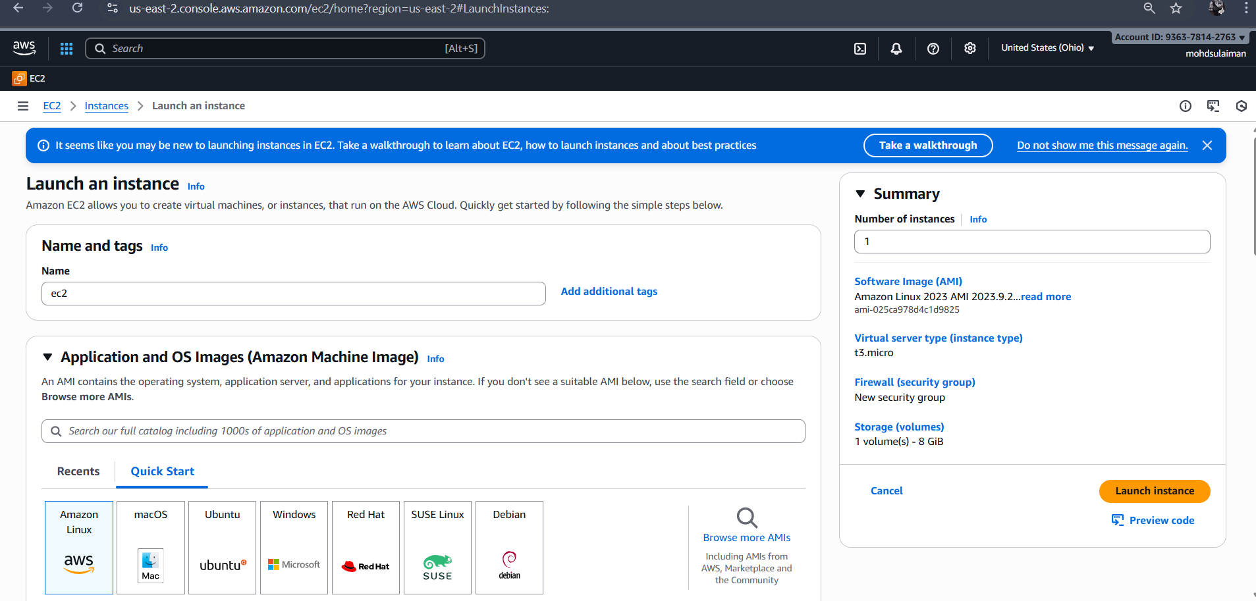
Install Docker.
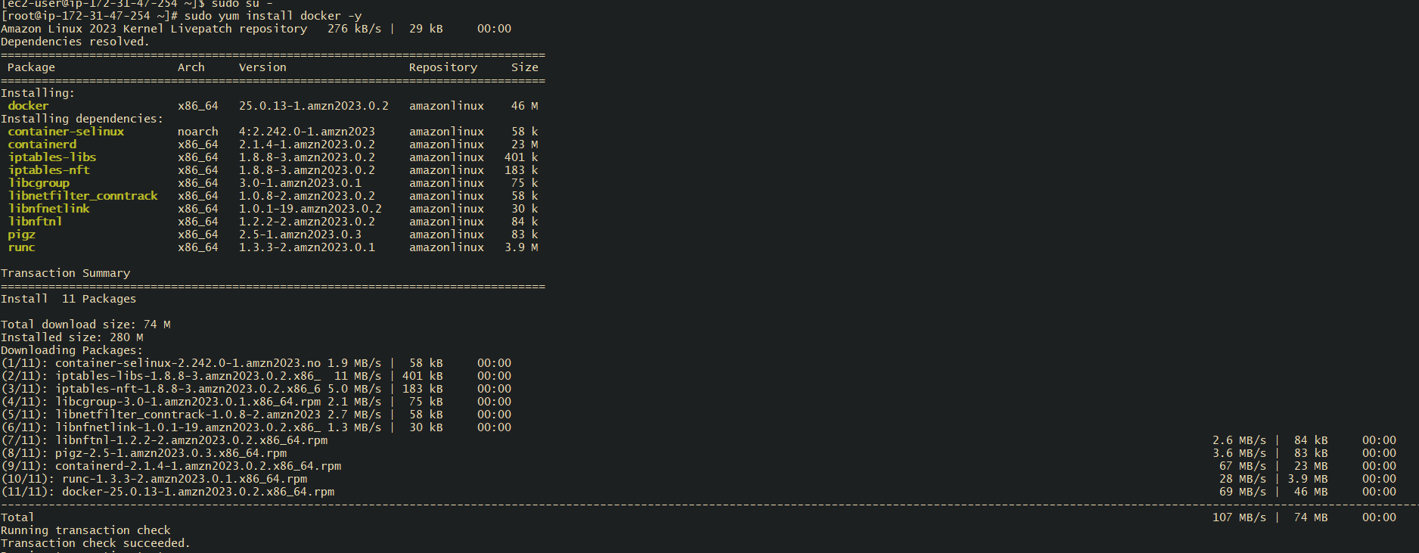

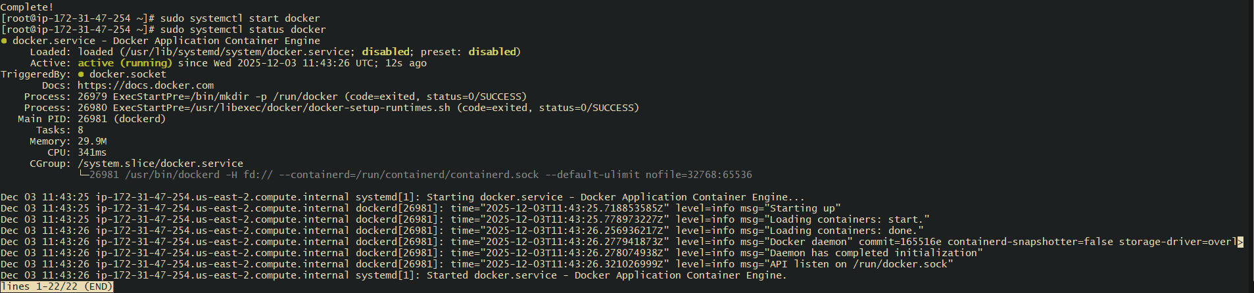

Install Jenkins.
Install java
Check the version of java
Check the version of java
Java –version
First install java if not install just type :- sudo dnf install java-17-amazon-corretto –y
After this check version : java –version ( after it just in case )

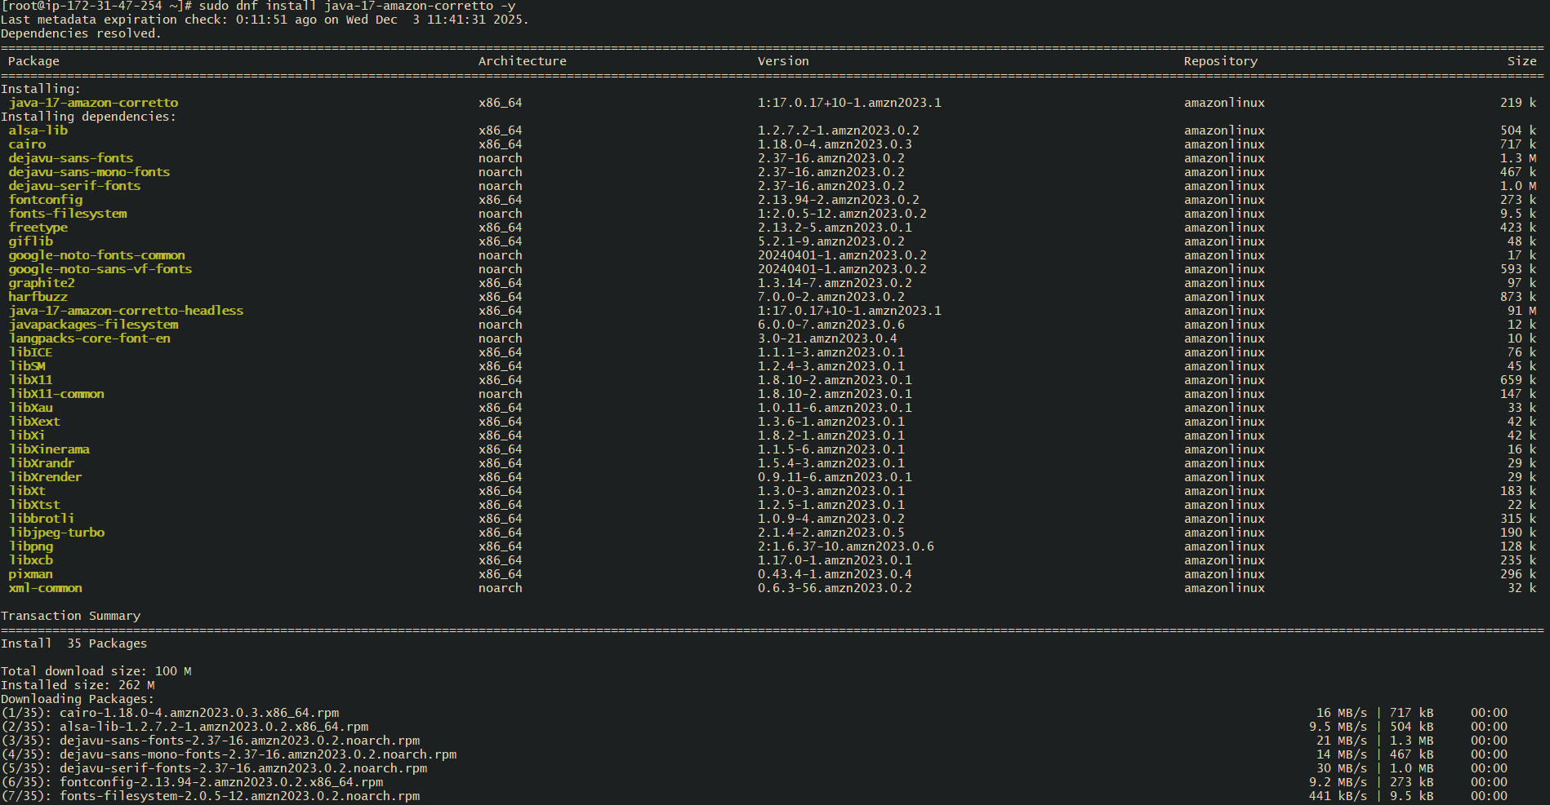
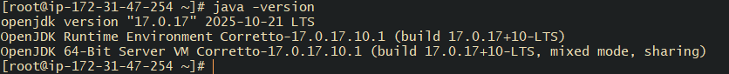

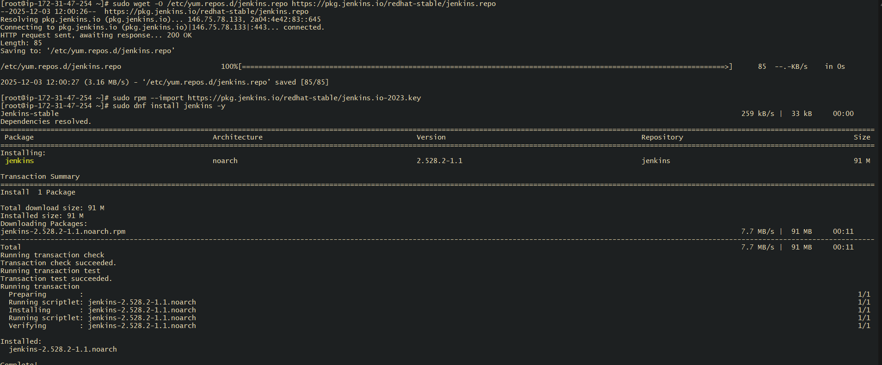
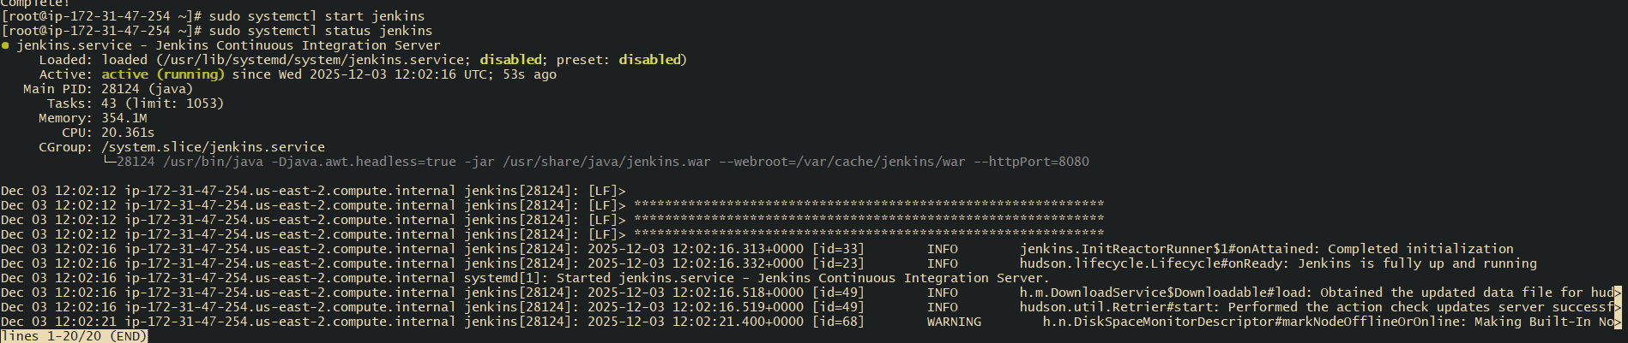
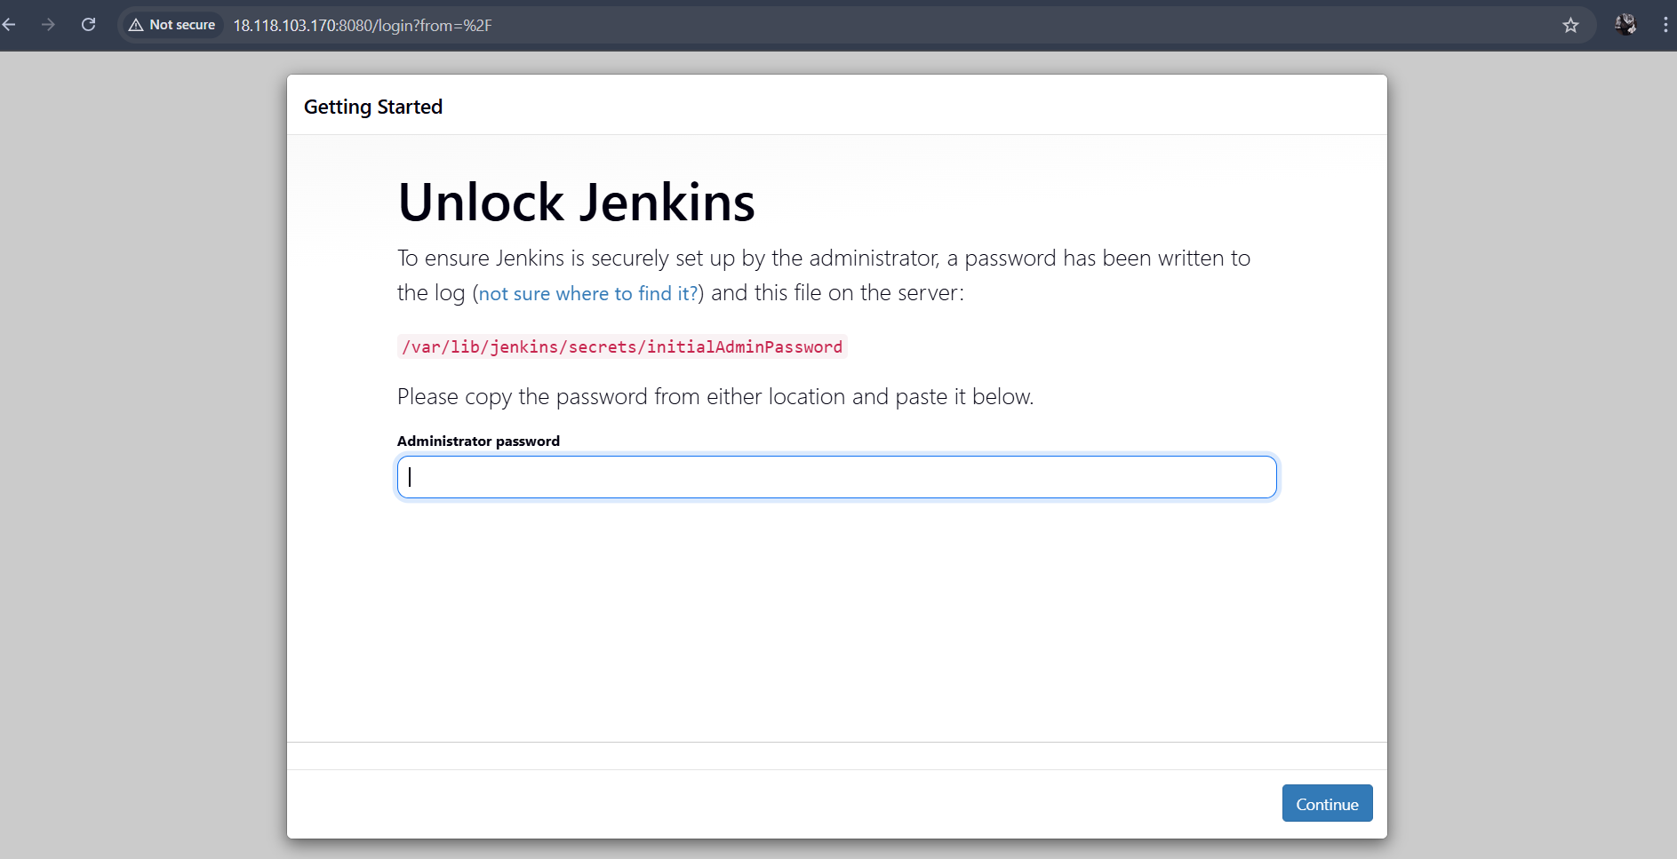
To view the just type in git bash cat cat/var/lib/jenkins/secrets/initialAdminPassword

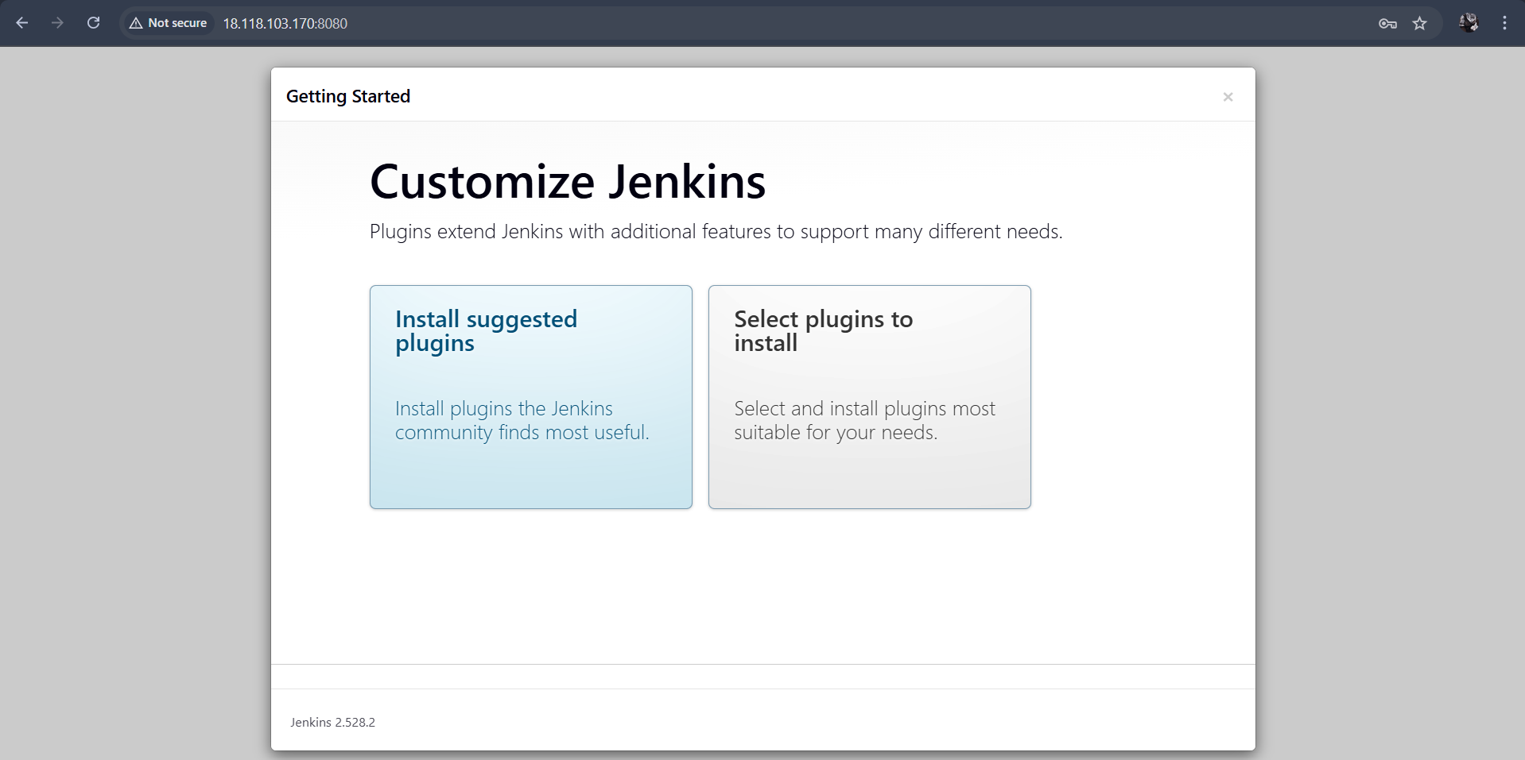
Set as per your requriments
Install Apache.
Install httpd -y
Start
Status
Make sure that port is 80
Then only
Copy the public ip

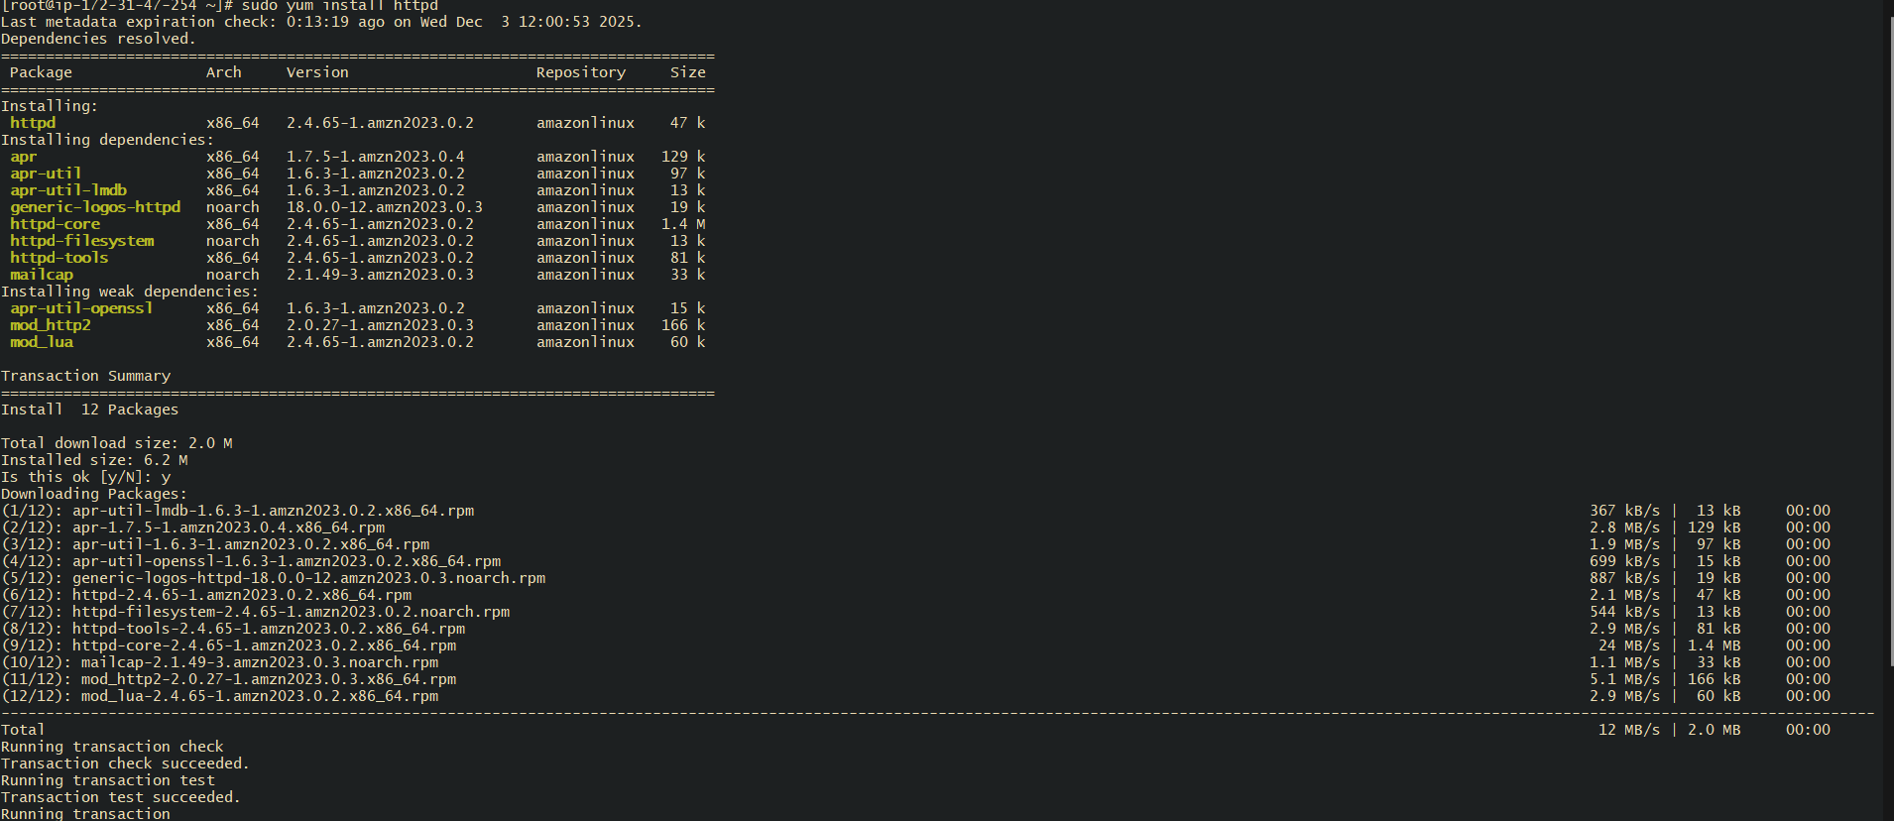

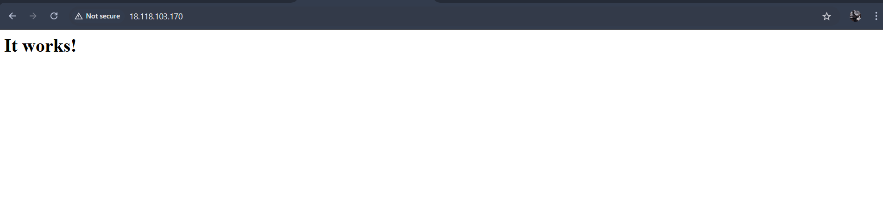
Install Apache Tomcat
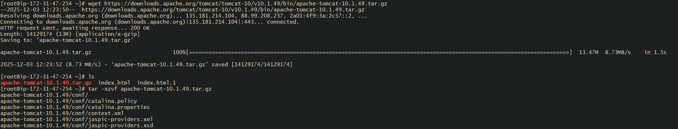
After wget : unpack it all our packages
Now type your public add : 8080 is it defult port number
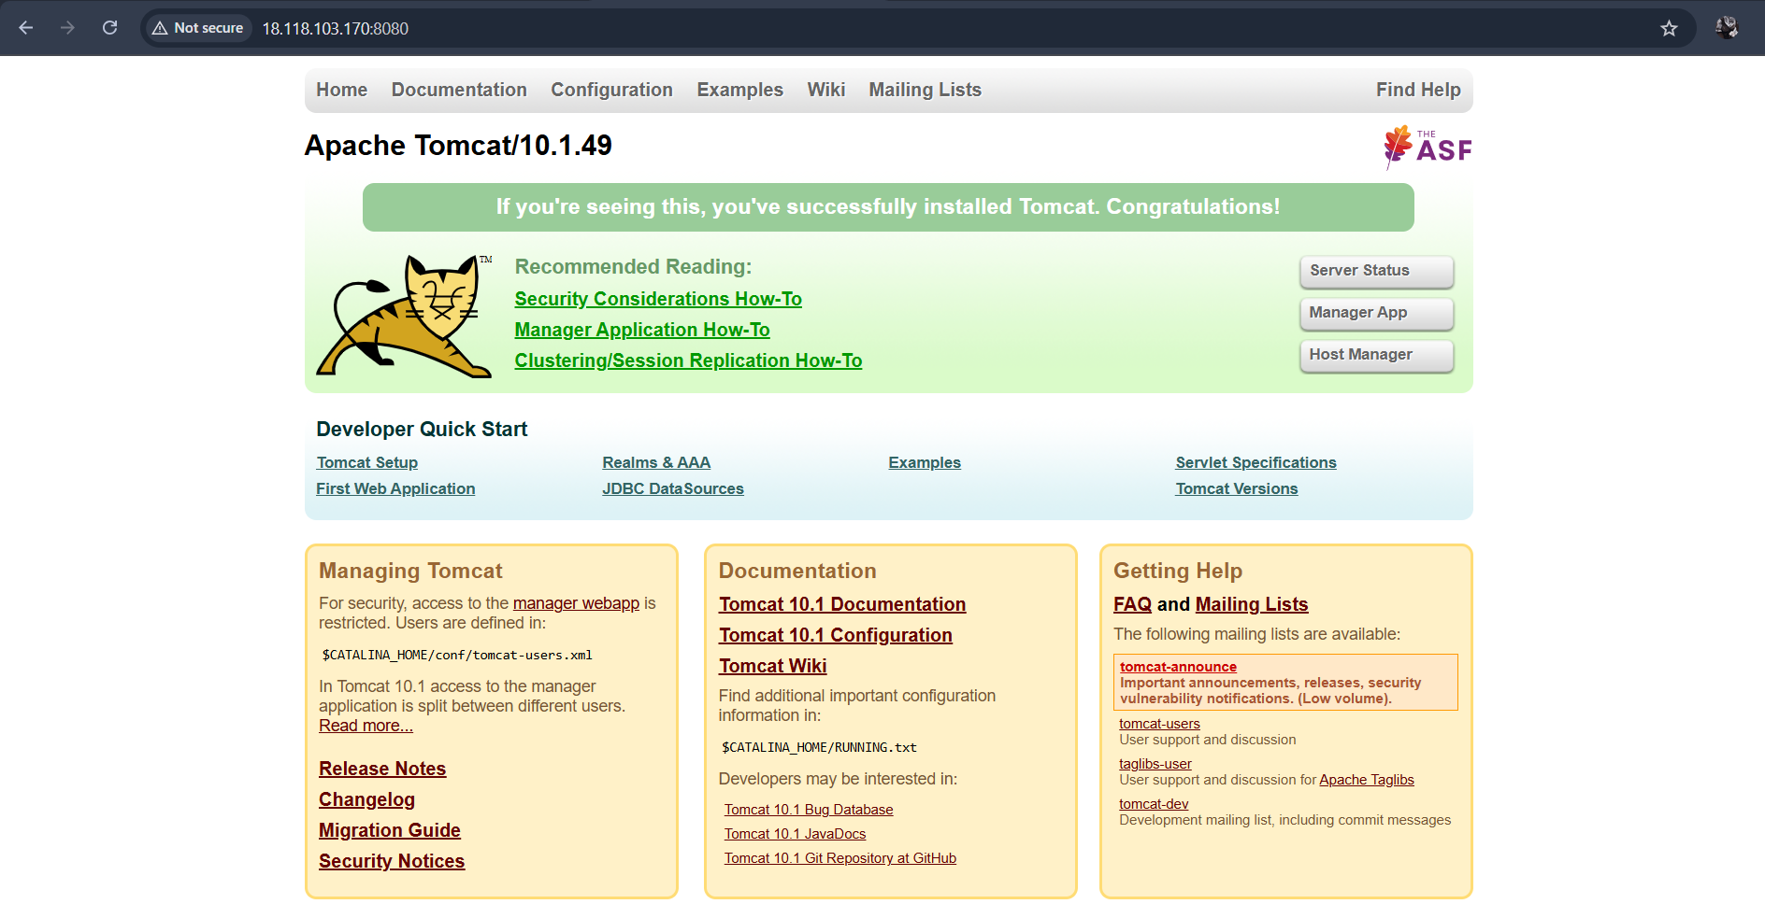
Thanks for reviving my challenge

